Problem Solution Fit

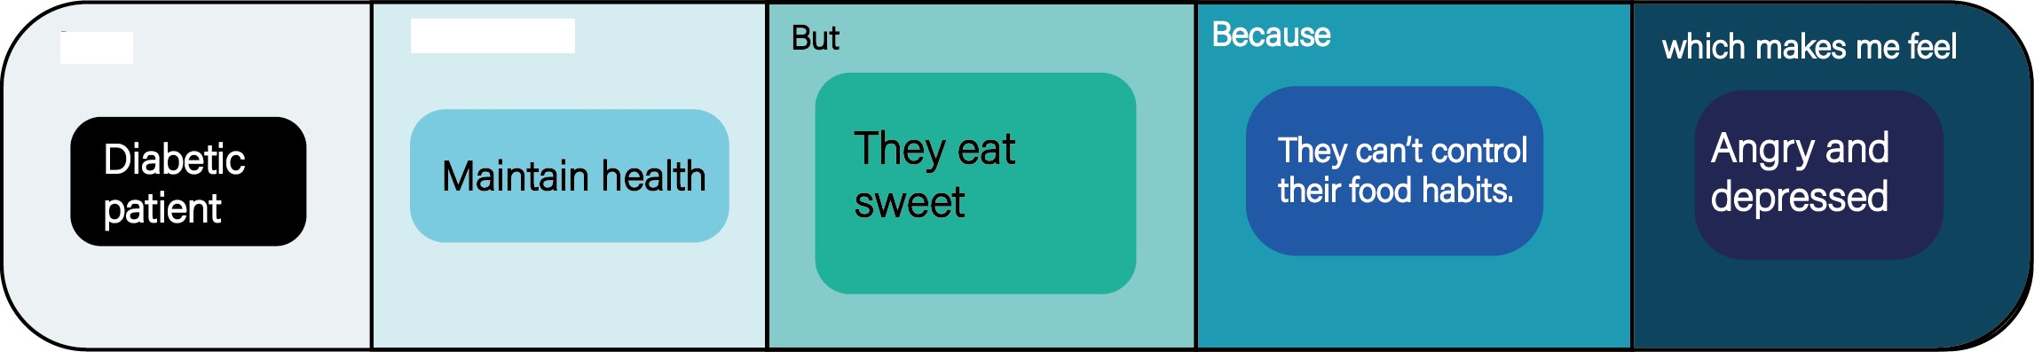

I am

I'm trying to

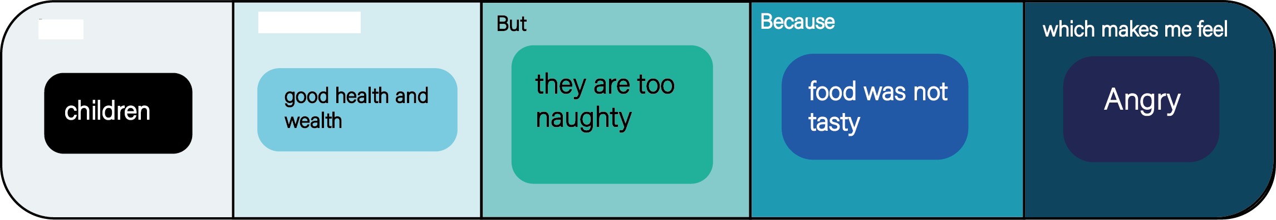

I am

I'm trying to

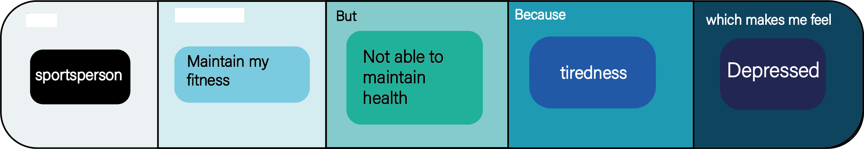

I am

I'm trying to

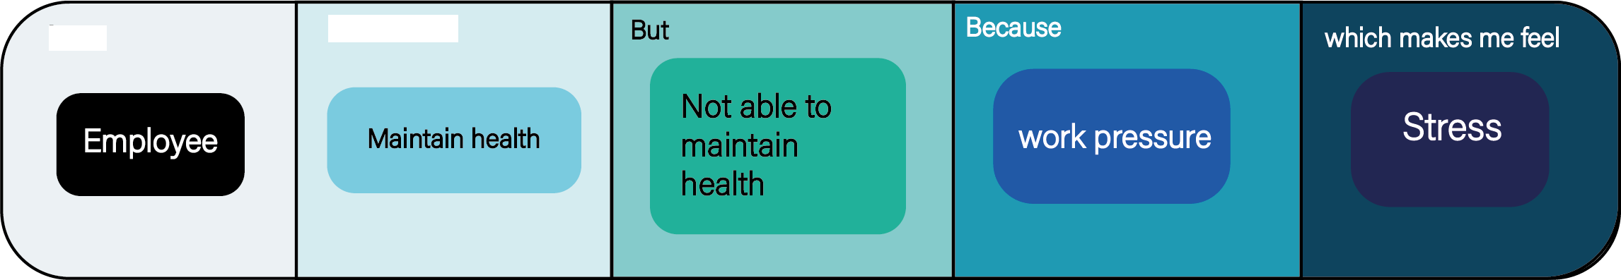

I am

I'm trying to

Date : 26/10/22

Team ID : PNT2022TMID36873

Project Name : AI Powered Nutrition Analyzer For Fitness Enthusiasts

Problem 1

Problem 2

Problem 3

Problem 4